
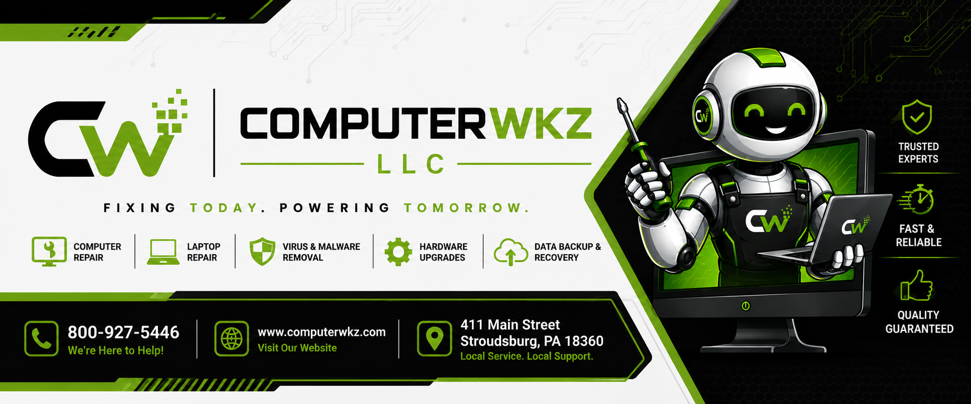

Computerwkz LLC Yearly & Monthly Maintenance Contract
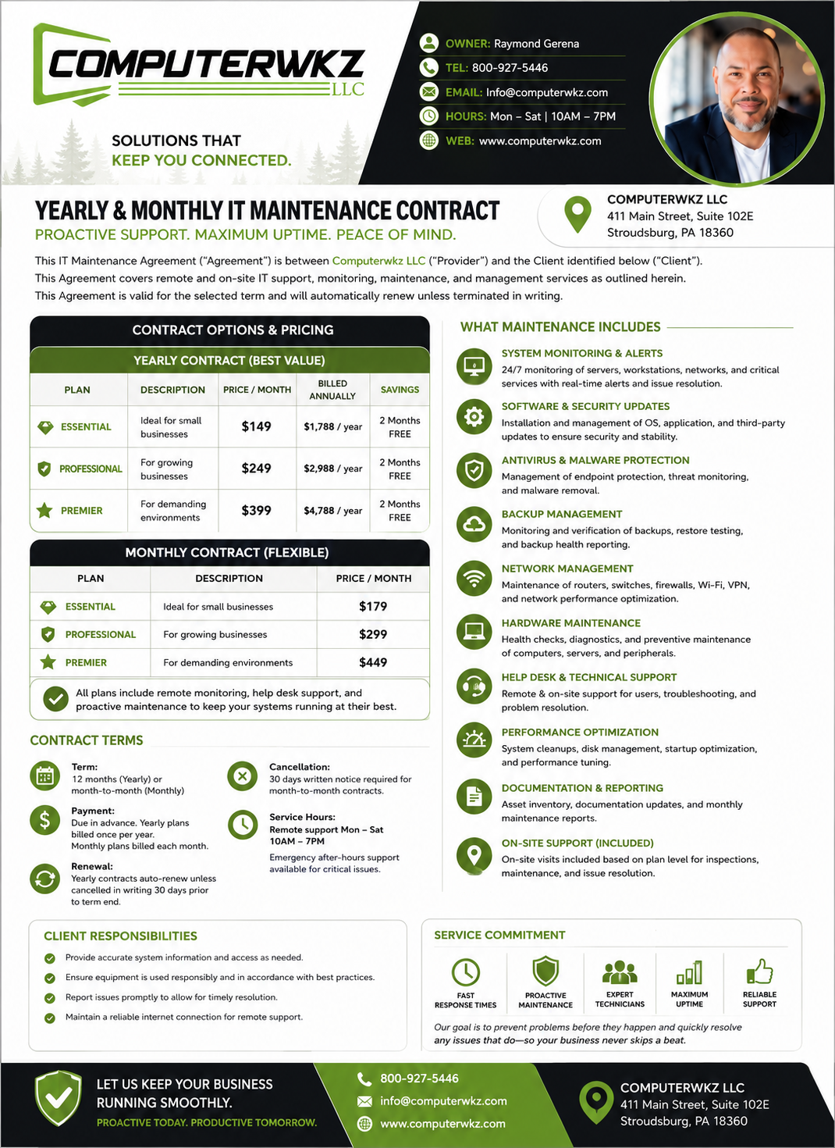

Client Information
Company Name: ______________________________
Contact Name: ______________________________
Address: ___________________________________
Phone: _____________________________________
Email: ______________________________________

Contract Options
Yearly Contract – Priority Support, Preventative Maintenance, Annual Billing.
Monthly Contract – Flexible Month-to-Month Managed Services.

Maintenance Includes
- 24/7 Monitoring & Alerts
- Software & Security Updates
- Antivirus & Malware Protection
- Backup Management
- Network Management
- Hardware Maintenance
- Help Desk & Technical Support
- Performance Optimization
- Documentation & Reporting
- On-Site Support Visits

Service Coverage
IT Infrastructure, Servers, POS Systems, Self-Checkout, Wide Format Printing, Photo Labs, CTP, Thermal Printing, Inkjet Systems, Flexographic Equipment.

SLA Response Times
Priority 1: 2 Hours | Priority 2: 4 Hours | Priority 3: 8 Hours | Priority 4: 1 Business Day
Client Signature: ______________________ Date: __________
Computerwkz LLC: ______________________ Date: __________

